2.1 What is CSS ? Explain inline ,internal and external css with examples.
Ans. CSS(cascading style sheet)is basically the language that controls how a webpage looks. While HTML puts the content on the page, CSS decides the colors , fonts ,spacing , background and the overall layout.
It helps to keep the design separate from the actual content ,which makes the website easier to update and manage . one of the biggest advantage of css is that the same styling can be applied to many pages at once , so the whole site looks neat and consistent.
CSS can be used in three main ways :
- Inline CSS
- Internal CSS
- External CSS

- Inline CSS :
In Inline CSS , we write the style directly inside the HTML tag .
It is usually used when you want to make a quick or very small change in one or particular part of page, like changing the color
of one heading or adjusting the size of a single paragraph.

Input:
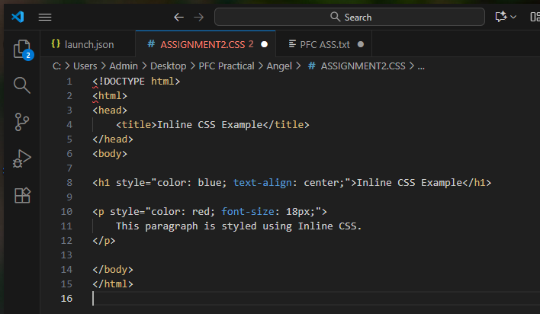

Output :

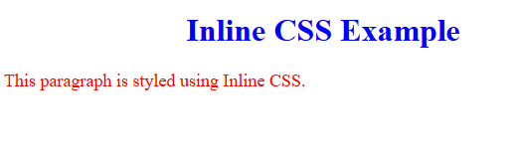

- Internal CSS :
It is written inside the <style> tag within the <head> section of an HTML document .This is useful when you want to style the entire page in one place without creating a separate CSS file .
It keeps the page organized and allows multiple element to share the same style .But the styling remains limited to that one page only .
If your website has many pages Internal CSS repetitive.
Input :
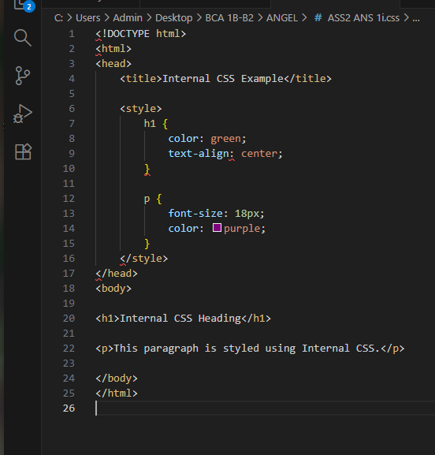
Output :
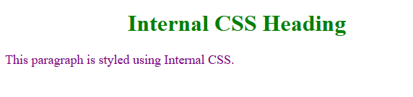

- External CSS
External CSS is considered the most professional and clean method . Here all the codes are written in a separate css file and the HTML page links to that file using the <link>tag .
It saves time ,reduces repetition and keeps both HTML and CSS file neat and well organized .
External CSS makes the website easier to update - changing one line in the CSS file can instantly update the design across the whole site .
Input :
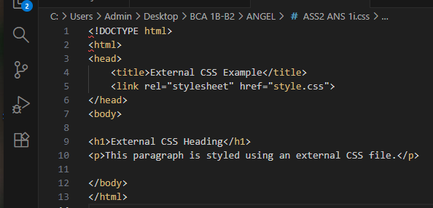

Output :

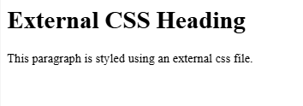
2.2 Write CSS rules to style headings in blue and paragraph with 16px font-size and justified alignment .
Ans : CSS rules allow us to control how different elements on a webpage should look . Each rules contains a selector which tells the browser which element we want to style ,using a set of properties that define how that element should appear.
Here are the following rules :
- Rule 1 : Select the heading element and set its color to blue.
- Rule 2 : Select the paragraph element and assign it a 16px fontsize
- Rule 3 : Apply text-align: justify; to the paragraph so that the text stretches evenly across the width of the page .
Input :
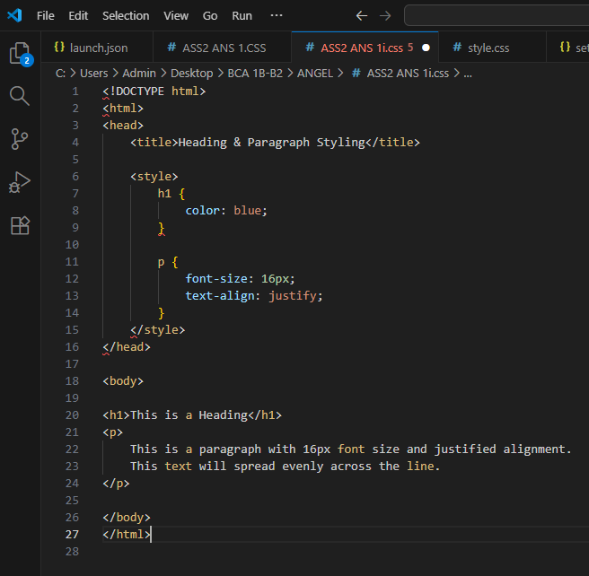
Output:
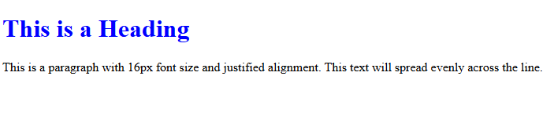
2.3 Explain the concept of the CSS Box Model with a diagram .
Ans : The CSS Box Model is a concept that explains how every element on webpage is structured and how space is calculated around it .
Every HTML element behaves like a box and this box is made up of four layers determine how much space an element takes and how it appears on the page.
The four layers of Box Model are :
- Content : This is the actual text ,image or data inside the element.
- Padding : It is the space between the content and the border. It creates space within the element.
- Border : A line that wraps around the padding and the content .
- Margin : The outermost area that creates the space between the element and the surrounding elements.
Input :
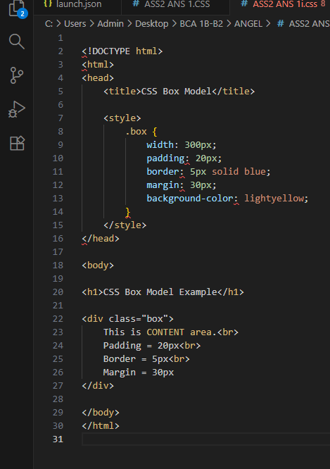

Output:

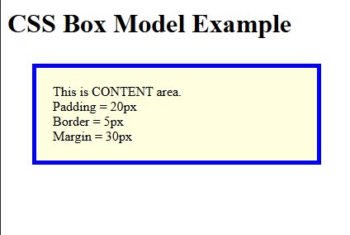

2.4 create a responsive two column layout using flexbox.
Ans : A responsive two column layout is a layout where two sections appear side by side on larger screen, but automatically stack on top of each other on smaller screens like mobile phones .Flexbox makes this very easy and responsive because it allows elements to adjust themselves based on the available space.
Input :
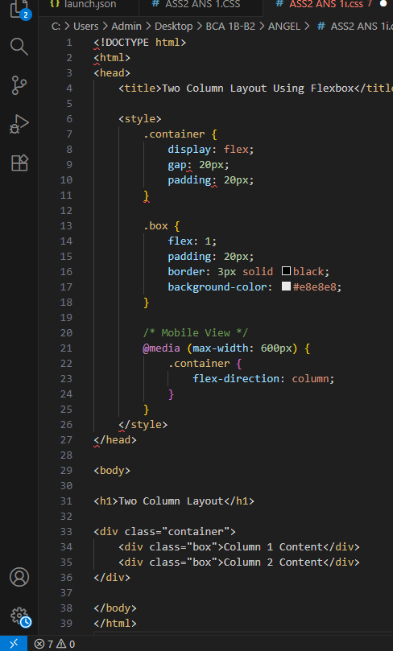

Output :

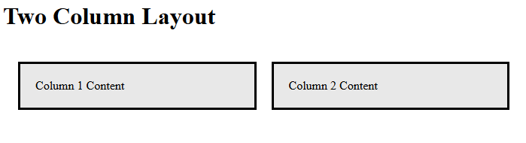

2.5 Develop a responsive responsive design using media queries for mobile and desktop views.
Ans : Responsive design makes a webpage adjust its look based on the screen size. Media queries help us to apply different styles for mobile and desktop. On large screens the layout looks spacious and on smaller screens it becomes compact so the content fits properly .This ensure the website is easy to reach and use on any device.

. 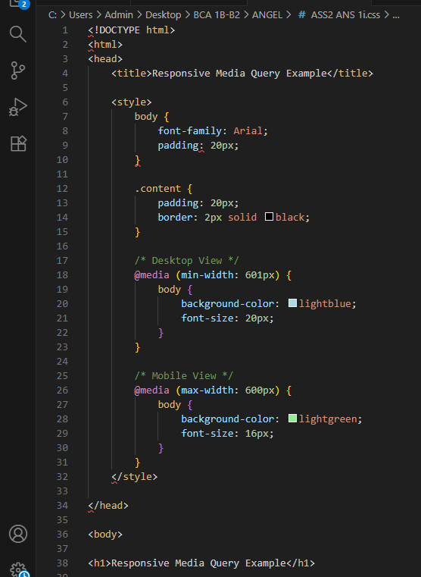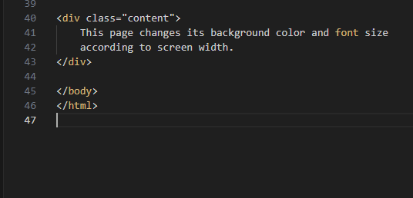

Output :

